# Lab 10a: Create a basic Web API

# using Express & Sequelize

**IDE: You need to work with a local IDE like VScode for this lab.**

**If MySQL is installed in your machine and you intend to use it skip part A and go to part B**

1. **First part: prepare the Cloud Aiden database server**
2. Open the website <https://aiven.io/> and create an account (get started for free). Signup and login. Choose to use the “personal” plan. Once logged in, on the services page, select MySQL then “free plan” and “create free service”.
3. In the registration page, enter your name, project name (for example se371). Then keep the default “connect with general”. Skip all other steps. You should get this page with all the connection details you need. Go to the databases tab and create a new database “se371db”:

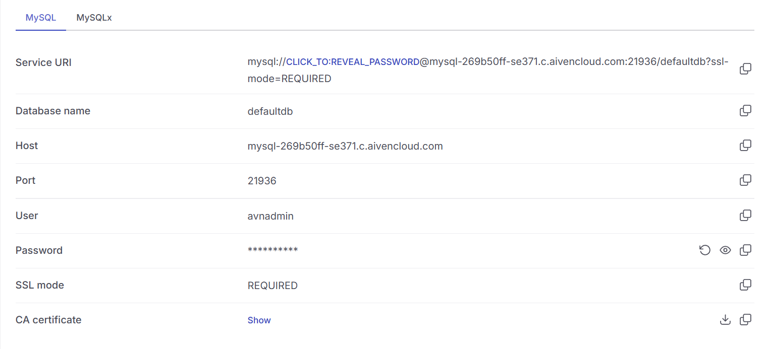

1. **Second part: prepare your web server (node/express)**
2. Install the node_modules declared in the package.json file using npm install.
3. Open the (.env) file and add your **own** configuration of the PORT for the node server, Then for the database server DB_NAME, DB_HOST, DB_USER, DB_PWD and DB_PORT.

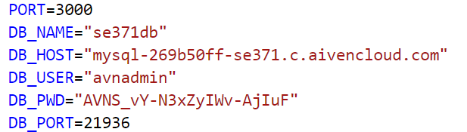

Figure. The .env file

1. Checkout the config/database.js file: It is loading the .env values (imported from app.js).
2. You will work on the model in model/country.js to define the schema of the Countries table. A country has:
   1. An id with the integer datatype and is a primary key.
   2. A name that is a String and is unique
   3. A phone_code that is a String and is unique
3. In app.js, import the Country model.
4. Create the web API endpoint of a get reauest that will return all the countries.
5. Create the web API endpoint of a Post request that can be used to add a new country in the database.

You can test your route using the thunder client VScode extension: using a POST request to for example (note that you have to replace localhost by [::1] which is the localhost in ipV6) if you are using a local server

http://[::1]:3000/api/countries/v1/

8. (OPTIONAL) Create a simple front-end to display all countries and a form to add a new country.

END.